**DAILY ONLINE ACTIVITIES SUMMARY**

|  |  |  |  |  |  |  |  |  |
| --- | --- | --- | --- | --- | --- | --- | --- | --- |
| **Date:** | **06/06/2020** | | | | | **Name:** | **VIRESH** | |
| **Sem & Sec** | **4th SEM & ‘B’ SEC.** | | | | | **USN:** | **4AL18CS097** | |
| **Online Test Summary** | | | | | | | | |
| **Subject** | | **Data Communication** | | | | | | |
| **Max. Marks** | | **30** | | **Score** | | | **26** | |
| **Certification Course Summary** | | | | | | | | |
| **Course** | **Introduction to Cyber Security** | | | | | | | |
| **Certificate Provider** | | | **Greatlearning Academy** | | **Duration** | | | **7.0 Hrs.** |
| **Coding Challenges** | | | | | | | | |
| **Problem Statement 1:** Write a program in C to rotate an array by N positions.  **Problem Statement 2:** Write a Java Program to find the second-highest number in an array. | | | | | | | | |
| **Status: Done** | | | | | | | | |
| **Uploaded the report in Github** | | | | | **Yes** | | | |
| **If yes Repository name** | | | | | **Lockdown-Coding**  <https://github.com/viresh-kulal/Lockdown-Coding>  <https://github.com/alvas-education-foundation/Viresh/tree/master/coding_solutions> | | | |
| **Uploaded the report in slack** | | | | | **Yes** | | | |

**Online Test Summary:** **18CS46 test was scheduled from 9:30am to 10:10am .The portion for the IA was 5th module there were 30 questions and the time assigned was 45 minutes the questions were MCQ type.**

**The snapshot of completion of test and the marks obtained in 18CS46 is attached below.**

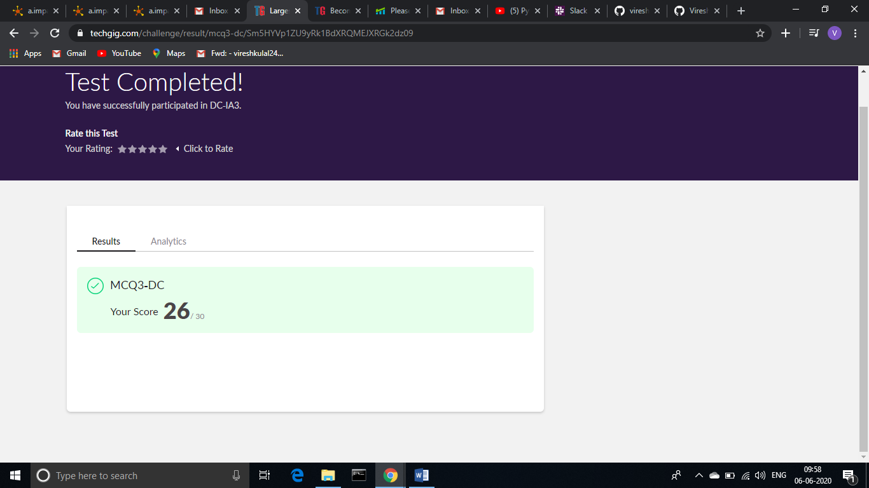

**Online Certification Course Summary: In today’s session I have learnt about Governance and Risk in Cyber Security and also learnt about Introduction to Cryptography what exactly cryptography is and encryption.**

**The snapshots of today’s session is attached below.**c

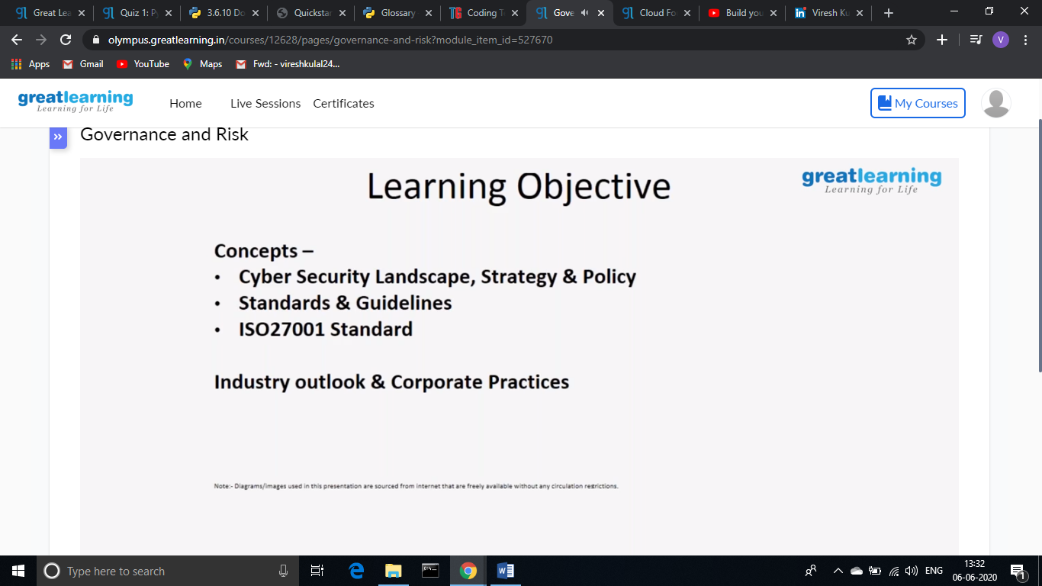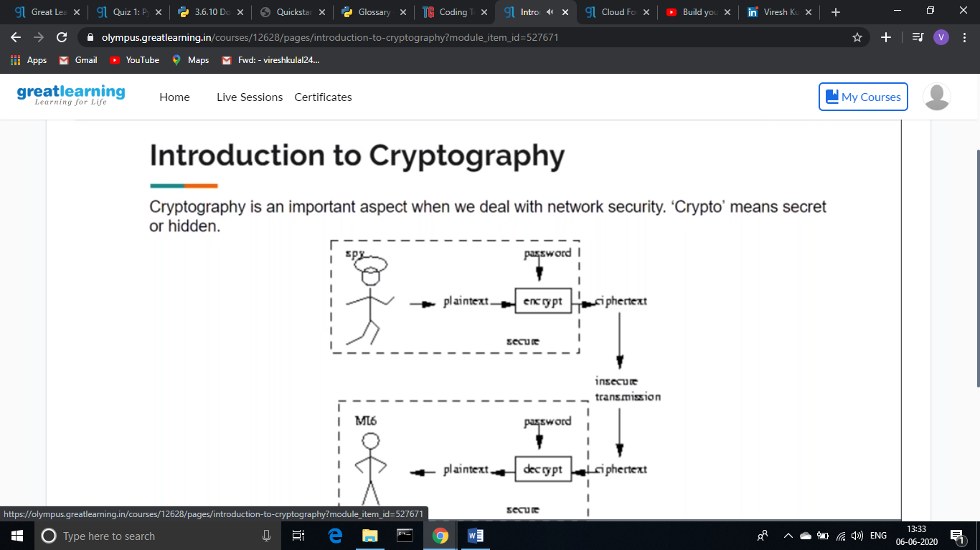

**Online Coding Summary: Today I had received one program from prof. Venkatesh CSE Dept. the other from Prof. Reena Lobo CSE Dept. and Prof. Shilpa CSE Dept. The program is mentioned above (pg.01). I have also uploaded it to my Github repository.**

The Repository link is: <https://github.com/viresh-kulal/Lockdown-Coding>

<https://github.com/alvas-education-foundation/Viresh/tree/master/coding_solutions>

**It is the snapshot of my repository where I have uploaded the code. File name is SecondLargest.java, Count.java and rotation.c**

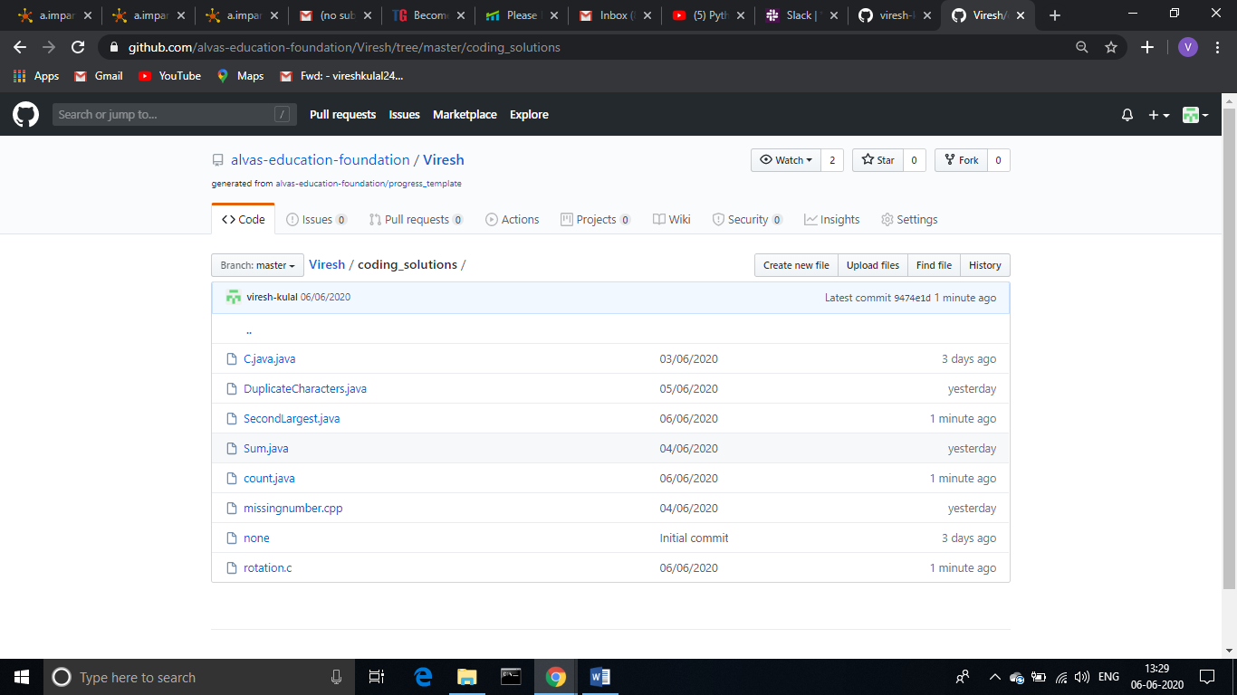

**Thank you.**